Flow 1, Week 2, Exercises

# Tuesday:

<https://dat3-2019fall.netlify.com/Flow-1/week2/27-08-2019/>

<https://docs.google.com/document/d/1RbYJ9hyiqSSASZfuWQtsKwFv7ngQP1-4dceRrKy1LzA/edit>

*You can do most of the exercises in this document by yourself, but they are meant as exercises with a supplementary discussion in the class, so you will gain a lot more from participating in the class.*

### Understanding Basic Network Terms like IP, TCP/IP, DNS, DHCP and more.

Most of these exercises are meant to be answered with text, so write down your reply so you will remember.

Windows commands in cmd prompt:

* ipconfig /all
* netsh
* trackert <address>
* **What is your public IP address right now, and how did you find it?**
  + I looked at my VPN
  + Or with Google or any of the other tools. 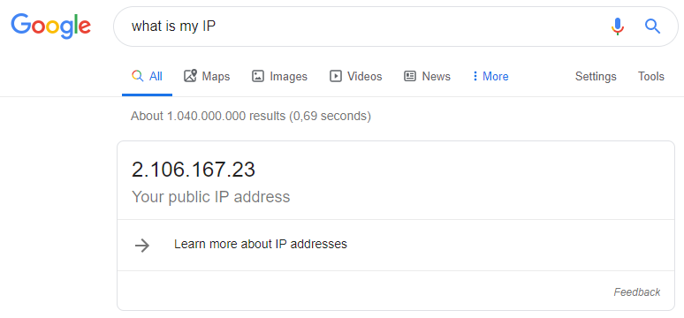
* **What is your private IP address right now (do this both at home and in school), and who/what gave you that address?**
  + 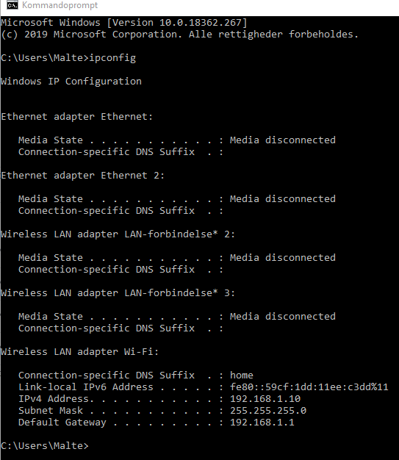
  + Windows Button -> cmd -> Command Prompt -> type in “ipconfig”
  + My router gave me this address.
  + At school: 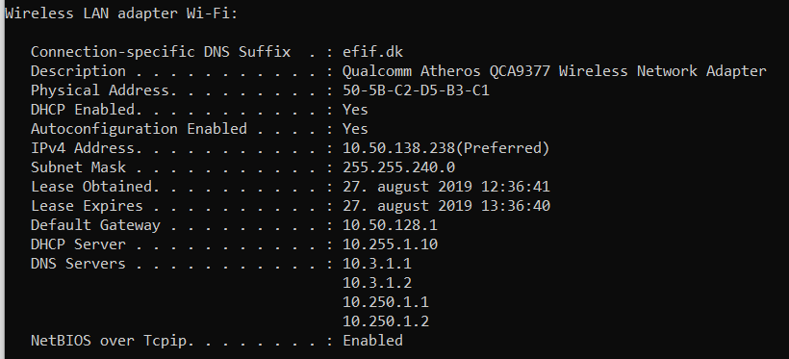
* **What’s special about these address ranges?**
  + 10.0.0.0 – 10.255.255.255
  + 172.16.0.0 – 172.31.255.255
  + 92.168.0.0 – 192.168.255.255

Answer: Private Network IP addresses.

Three non-overlapping ranges of IPv4 addresses for private networks are reserved. These addresses are not routed on the Internet and thus their use need not be coordinated with an IP address registry. Any user may use any of the reserved blocks. Typically, a network administrator will divide a block into subnets; for example, many home routers automatically use a default address range of 192.168.0.0 through 192.168.0.255 (192.168.0.0/24).

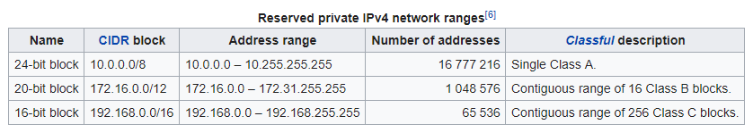

* **What’s special about this ip-address: 127.0.0.1?**
  + 
  + Det er ens egen computers IP address. Home. Localhost.
* **What kind of service would you expect to find on a server using these ports:** 
  + **22:** Secure Shell uses port 22. SSH servers listen on this port for incoming login requests from remote clients.
  + **23:** Port 23 governs telnet, a text-based system for logging into remote systems. Although modern remote-access approaches rely on Secure Shell on port 22, port 23 remains reserved for the older and less-secure telnet application.
  + **25:** Email relies on several standard ports. Port 25 governs the Simple Mail Transfer Protocol — the tool by which an email on your computer makes its way to a mail server, and then from that server to the larger internet for routing and delivery.
  + **53:** DNS
  + **80:** When you request a website from your web browser, the browser communicates over port 80 for HTTP, so the data is then sent back over that same port and displayed within the program that supports that port (the web browser).
  + **443:** Port 443 is the default for secure HTTP. HTTPS.
* **What is the IP address of studypoints.dk and how did you find it?**
  + 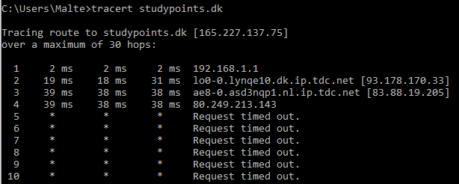
* **If you write https://studypoints.dk in your browser, how did “it” figure out that it should go to the IP address you discovered above?**
  + It contacts a DNS server that it knows from the list: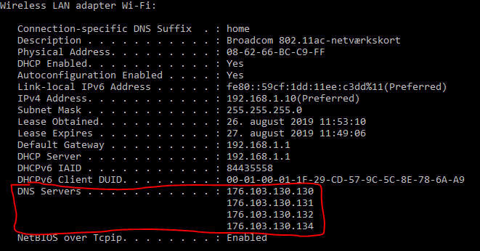
  + From there, the DNS server will find the path to the website in the network. Use the “tracert” command to show that route.
* **Explain shortly the purpose of an ip-address and a port-number and why we need both**
  + An IP-address is the location of your device on the network. A public IP address is necessary for communication between hosts on the global network.
  + Port numbers allow different services to share network resources simultaneously.
  + The IP address identifies the destination device and the port number identifies the specific destination service.
* **What is your (nearest) DNS server,?**
  + I’ve heard that googles is the fastest: <https://developers.google.com/speed/public-dns/> - But it is probably not the nearest. A DNS’ speed has to do with more than just physical proximity.
  + My current on my PC is “dns-vultr-fra-2” - But I’m not sure if it is the closest.
* **What is (conceptually) the DNS system and the purpose with a DNS Server?**
  + It is the phone book of the internet. Domain Name Server.
  + The internet is made up of “nodes”, and you need to find the route through them to your destination (IP). DNS helps with that.
  + It can translate a website “[www.something.com](http://www.something.com)” into an IP “103.13.123.44”
* **What is your current Gateway, and how did you find it?**
  + 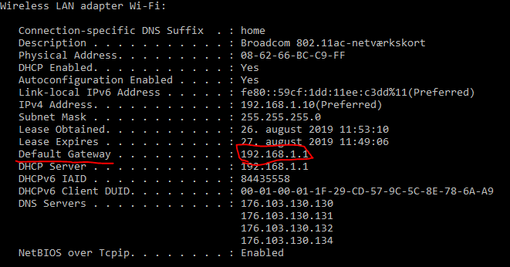
  + ipconfig /all command in cmd prompt
* **What is the address of your current DHCP-Server, and how did you find it?**
  + 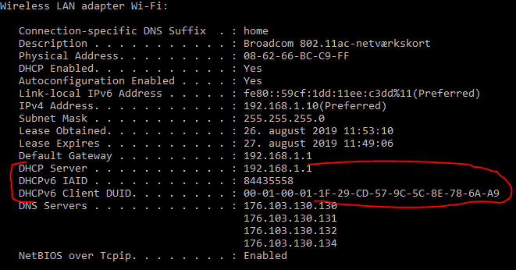
  + ipconfig /all command in cmd prompt
  + DHCP == Dynamic Host Configuration Protocol
    - It avoids the burden of assigning specific static addresses to each device on a network.
    - With the DHCP you get a lease. You can see “Leasy Obtained” and “Lease Expires” in the screenshot above.
* **Explain (conceptually) about the TCP/IP-protocol stack**
  + It has four layers:
    - Datalink - bit
      * Ethernet for example. Only directly linked nodes on the network.
    - Internet / Networking - frame
      * Uses IP. Connects networks to allow them to communicate.
    - Transport - segment
      * TCP - UDP. Handles the communication. Flow control, reliability, multiplexing.
    - Applications
      * Data exchange between apps. HTTP. Also FTP, POP3, SMTP, SNMP. (HyperText Transfer Protocol, File Transfer Protocol, Post Office Protocol Version 3, Simple Mail Transfer Protocol, and Simple Network Time Protocol)
  + TCP opdeler en besked i pakker der kan sendes over nettet. De indeholder en header og IP. IP-adressen er der hvor pakken skal hen.
* **Explain about the HTTP Protocol (the following exercises will go much deeper into this protocol)**
  + Hypertext Transfer Protocol
  + It is a protocol to provide data exchange between applications.
* **Explain (conceptually) how HTTP and TCP/IP are connected (what can HTTP do, and where does it fit into TCP/IP)**
  + HTTP is in the Applications layer of TCP/IP and is a protocol for Data Exchange between applications.